Windows Updates
Getting Windows updates.
- Locate the “Search” box at the bottom of your screen next to the Windows logo.
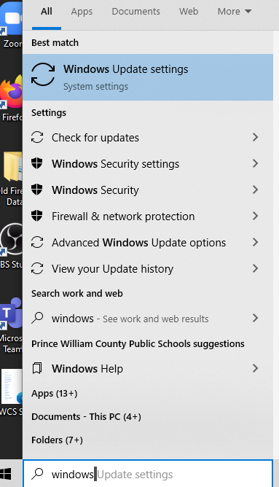

- Type “Windows Update Settings” in the Search box

- Click “Check for Updates” even if it says, “You’re up to date”.

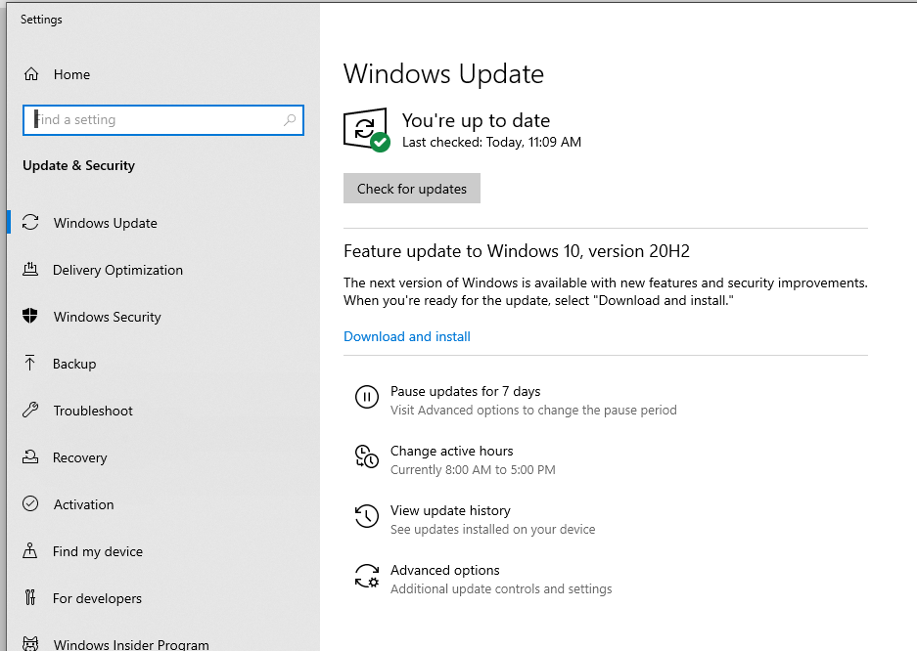
- You will see a list of updates. If the list is long, you may have to click a button at the bottom of the list that says “Install Updates.”
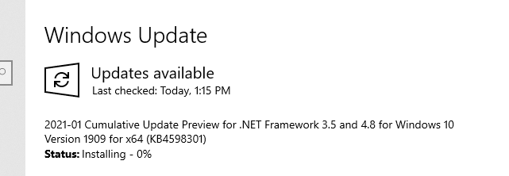

- You may need to restart your computer for some updates. You can do it immediately or tell the computer when you want it to restart. (Don’t forget to leave it on so it can restart)
